Academic Year | 2025-2026 | Estimated Time | 02 Hours
Course & Semester | S.E. CSE | Subject Name | Object Oriented Programming with Java Lab
Module No. | 10 | Chapter Title | JDBC Connections in Java
Experiment Type | Software Performance | Subject Code | PCC12CE07

Name of Student | Atharva Dharmendra Jagtap | Roll No. | 10937
Date of Performance: |  | Date of Submission:
CO Mapping | CO4: Develop and Debug Java Applications

Objective of Experiment: Database Connection with Java:Setting Up Database Environment (MySQL/PostgreSQL), Establishing Database Connection, Executing SQL Queries, basics of Exception Handling Demonstration Program on Database Connection and Queries handling
Pre-Requisite: Introduction to sql queries , Exception handling. Tools: Java IDE/Eclipse & mysql workbench
Theory:

JDBC Overview
JDBC (Java Database Connectivity) is an API that provides a standard way to interact with databases from Java applications. It acts as a bridge between Java and various databases, allowing you to perform tasks like:

- Connecting to databases
- Executing SQL queries
- Retrieving and manipulating data

- JDBC API is a Java API that can access any kind of tabular data, especially data stored in a Relational Database.
- JDBC works with Java on a variety of platforms, such as Windows, Mac OS, and the various versions of UNIX.
- The JDBC library includes APIs for each of the tasks mentioned below that are commonly associated with database usage.
- Making a connection to a database.
- Creating SQL or MySQL statements.
- Executing SQL or MySQL queries in the database.
- Viewing & Modifying the resulting records

Applications of JDBC

- Fundamentally, JDBC is a specification that provides a complete set of interfaces that allows for portable access to an underlying database. Java can be used to write different types of executables, such as,
- Java Applications
- Java Applets
- Java Servlets
- Java ServerPages (JSPs)
- Enterprise JavaBeans (EJBs).
- All of these different executables are able to use a JDBC driver to access a database, and take advantage of the stored data.
- JDBC provides the same capabilities as ODBC, allowing Java programs to contain database- independent code.

Setting Up Database Environment (MySQL/PostgreSQL)

- Import the package: java.sql.*

- A) Load the Driver:
First import JDBC Driver:

  - Download the JDBC driver for your chosen database (MySQL Connector/J, PostgreSQL JDBC Driver) from the respective website. For mysql driver is (com.mysql.jdbc.Driver)
  - If you use eclipse then download the driver first.
  - Google- download mysql.connector.jar (download it from maven repository below is the link)
  - https://mvnrepository.com/artifact/mysql/mysql-connector-java
  - Add the downloaded JAR file to your Java project's classpath. This can be done using your IDE's build path settings or by manually including the JAR in the project directory.
  - Now add jar file to your project directory(steps for eclipse)
  - Right click on your project directory and goto build path - configure build path- Add external jars-and add file

2 B) Load the register

  - In your Java code, load the JDBC driver class using the Class.forName() method. For example:

Class.forName("com.mysql.cj.jdbc.Driver"); // For MySQL
// Class.forName("org.postgresql.Driver"); // For PostgreSQL

For creating table in database we use mysql workbench(download it from google) 3 Create a Connection/Establish a connection:
The DriverManager creates a Connection object to the database using the provided URL,
username, and password.

  - Use the DriverManager.getConnection() method to establish a connection to the database, providing the URL, username, and password:

String url = "jdbc:mysql://localhost:3306/your_database_name"; // For MySQL
// String url = "jdbc:postgresql://localhost:5432/your_database_name"; // For PostgreSQL String username = "your_username";
String password = "your_password";

Connection connection = DriverManager.getConnection(url, username, password);

- Statement Creation: A Statement object is created from the Connection object.

Create a Statement:

  - Create a Statement object using the connection.createStatement() method to execute SQL statements.

Statement statement = connection.createStatement();

- SQL Execution: The Statement object is used to execute SQL statements, which are translated into database-specific commands by the JDBC driver.

  - Use the executeQuery() method for SELECT statements to retrieve results: ResultSet resultSet = statement.executeQuery("SELECT * FROM your_table"); while (resultSet.next())
{

// Process the result set data

String columnValue = resultSet.getString("column_name"); System.out.println(columnValue);
}

  - Use the executeUpdate() method for INSERT, UPDATE, and DELETE statements to modify data:

int rowsAffected = statement.executeUpdate("INSERT INTO your_table (column1, column2) VALUES ('value1', 'value2')");

System.out.println("Rows affected: " + rowsAffected);

- Result Processing: The results of the query are returned as a ResultSet object, which can be iterated over to access the data.

- Resource Closing: The Connection, Statement, and ResultSet objects should be closed to release resources.

Example Code

import java.sql.Connection; import java.sql.DriverManager; import java.sql.Statement; import java.sql.ResultSet; import java.sql.SQLException;

public class Jdbc_Postgres {
public static void main(String[] args) {
String url = "jdbc:postgresql://localhost/postgres"; String user = "postgres";
String password = "postgres";

Connection conn = null; Statement stmt = null; ResultSet rs = null;

try {
// Load the PostgreSQL JDBC driver (optional for newer

versions)

Class.forName("org.postgresql.Driver");

System.out.println("Connecting to database...");
conn = DriverManager.getConnection(url, user, password); System.out.println("Connected to PostgreSQL database!");

stmt = conn.createStatement();
rs = stmt.executeQuery( "SELECT * FROM employee;" ); while ( rs.next() ) {
int id = rs.getInt("emp_id");
String name = rs.getString("emp_name");
//int age = rs.getInt("age");
//String address = rs.getString("address"); float salary = rs.getFloat("salary"); System.out.println( "ID = " + id ); System.out.println( "NAME = " + name );
//System.out.println( "AGE = " + age );
//System.out.println( "ADDRESS = " + address ); System.out.println( "SALARY = " + salary ); System.out.println();
}
rs.close();
stmt.close();

conn.close();
} catch ( Exception e ) {
System.err.println( e.getClass().getName()+": "+ e.getMessage()
);
System.exit(0);
}
System.out.println("Operation done successfully");
}
}

Problem Description:Write a Java program that connects to a PostgreSQL database, creates a table, inserts some records, and retrieves and displays those records.

Code:

import java.sql.Connection; import java.sql.DriverManager; import java.sql.Statement; import java.sql.ResultSet; import java.sql.SQLException;

public class exp10 {
public static void main(String[] args) {
String url = "jdbc:postgresql://localhost/postgres"; String user = "postgres";
String password = "NikhatKhan";

Connection conn = null; Statement stmt = null; ResultSet rs = null;

try {
// Load the PostgreSQL JDBC driver (optional for newer versions) Class.forName("org.postgresql.Driver");

System.out.println("Connecting to database...");
conn = DriverManager.getConnection(url, user, password); System.out.println("Connected to PostgreSQL database!");

stmt = conn.createStatement();
rs = stmt.executeQuery( "SELECT * FROM employee;" ); while ( rs.next() ) {
int id = rs.getInt("emp_id");
String name = rs.getString("emp_name");
//int age = rs.getInt("age");
//String address = rs.getString("address"); float salary = rs.getFloat("salary"); System.out.println( "ID = " + id );

System.out.println( "NAME = " + name );
//System.out.println( "AGE = " + age );
//System.out.println( "ADDRESS = " + address ); System.out.println( "SALARY = " + salary ); System.out.println();
}
rs.close();
stmt.close();
conn.close();
} catch ( Exception e ) {
System.err.println( e.getClass().getName()+": "+ e.getMessage() ); System.exit(0);
}
System.out.println("Operation done successfully");
}
}

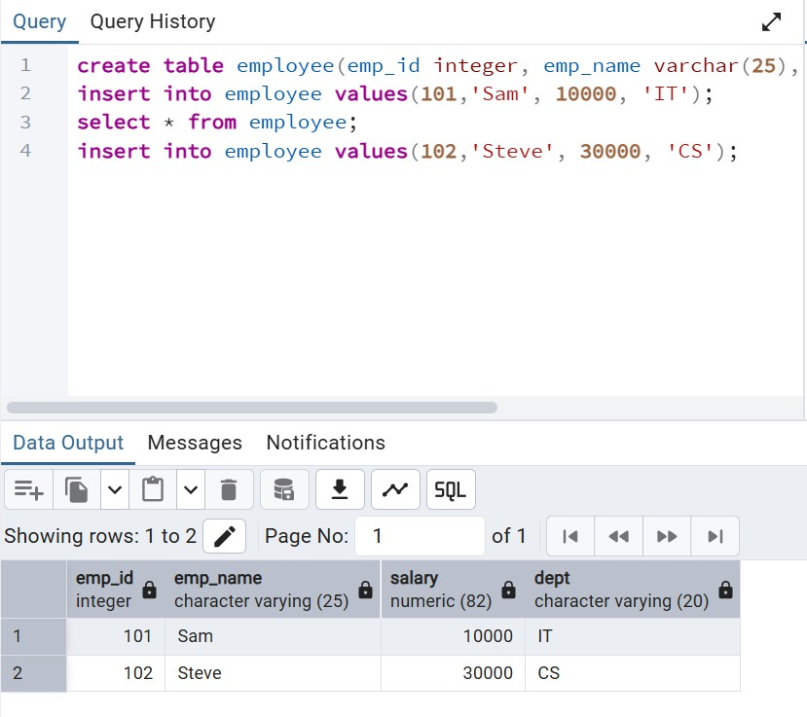
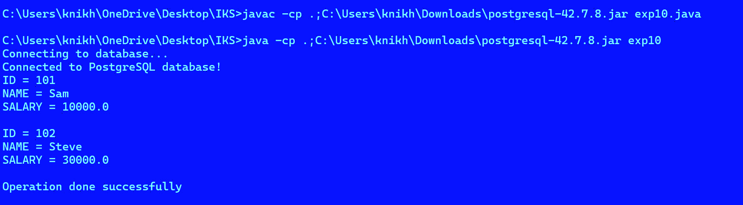
Output:

PostLabQuestions:

- Explain the difference between ResultSet Vs. RowSet vs in JDBC?
Ans. ResultSet holds query results and requires an active database connection. RowSet extends ResultSet, works in connected/disconnected modes, is serializable, event-driven, and ideal for mobile or offline use.

- What is a JDBC driver?
Ans. A JDBC driver enables Java applications to interact with databases by translating JDBC calls into database commands. Four types exist, with Type 4 (pure Java) most commonly used.

- What is ResultSet?
Ans. A ResultSet stores data retrieved from a SQL query, acting as a cursor to iterate through rows. It’s typically forward-only and read-only but can be scrollable or updatable.

On time Completion and Submission (2) | Knowledge of the topic (4) | Implementation and Output (4) | Total (10)

References:
Study Materials https://www.w3schools.com/java/ https://www.geeksforgeeks.org/java/ https://www.codecademy.com/learn/learn  -java | Video Channels: https://www.youtube.com/user/programmingwithmos h  https://www.youtube.com/c/TheNetNinja https://www.youtube.com/c/Freecodecamp https://www.youtube.com/user/Simplilearn
Study Materials used for Demo
<Add links here>

Note:-students are expected to paste screen shot of the program with output

